

Submission Date: 03-03-2025
Roll: 220638
SUBMITTED BY
JUBAYER AHMMED

Department of Information and Communication Engineering
Pabna University of Science and Technology

Dr. Md. Imran Hossain

Associate Professor
INFORMATION AND COMMUNICATION ENGINEERING

ICE-2204

Course Name: Signals and Systems Sessional
LAB REPORT
SUBMITTED TO:

PABNA UNIVERSITY OF SCIENCE AND TECHNOLOGY

Index

No | Experiment Name
01 | System Sequence: Analysis of Impulse Signal, Step Signal, and Ramp Signal
02 | Signal Operations: Addition, Multiplication, Scaling, Shifting, and Folding
03 | Correlation: Analysis of Autocorrelation and Cross-Correlation of Signals
04 | Convolution: Analysis of Autoconvolution and Convolution of Signals
05 | PPG Signal Processing: Heart Rate and Abnormality Detection.
06 | Fourier Series: Approximation of a Square Wave
07 | Fourier Series Decomposition: Analysis of a Square Wave
08 | Discrete Fourier Transform (DFT) and Inverse Discrete Fourier Transform (IDFT)

Experiment No: 01
Title:
System Sequence: Analysis of Impulse Signal, Step Signal, and Ramp Signal

Theory:

1. Impulse Signal:
An impulse signal, also known as a Dirac delta function, is a signal that is zero everywhere except at the origin, where it is infinitely high. However, its integral over time is 1. It is mathematically represented as:
$δ(t) =$ $\{_{0, t ≠ 0 }^{∞, t = 0}$
In discrete-time systems, the impulse signal is defined as:
$δ(n) =$ $\{_{0, n ≠ 0 }^{1, n = 0}$
2. Step Signal:
A step signal, also known as the unit step function, is a signal that is zero for all negative time and one for all positive time. It is mathematically represented as:

$u(t) =$ $\{_{0, t< 0 }^{1, t ≥ 0}$
In discrete-time systems, the step signal is defined as:
$u(n) =$ $\{_{0, n< 0 }^{1, n ≥ 0}$

3. Ramp Signal:
A ramp signal is a signal that increases linearly with time. It is mathematically represented as:
$r(t) =$ $\{_{0, t< 0 }^{t, t ≥ 0}$
In discrete-time systems, the ramp signal is defined as:
$r(n) =$ $\{_{0, n< 0 }^{n, n ≥ 0}$

Source Code:

import numpy as np
import matplotlib.pyplot as plt

# Define the range
n = np.arange(-10, 11)

# Define functions for signals
def impulse_signal(n):
return np.where(n == 0, 1, 0)

def step_signal(n):
return np.where(n >= 0, 1, 0)

def ramp_signal(n):
return np.where(n >= 0, n, 0)

# Generate signals
impulse = impulse_signal(n)
step = step_signal(n)
ramp = ramp_signal(n)

# Plot signals
plt.figure(figsize=(12, 4))

# Impulse Signal
plt.subplot(1, 3, 1)
plt.stem(n, impulse)
plt.title("Impulse Signal")
plt.xlabel("n")
plt.ylabel("Amplitude")
plt.grid()

# Step Signal
plt.subplot(1, 3, 2)
plt.stem(n, step)
plt.title("Step Signal")
plt.xlabel("n")
plt.ylabel("Amplitude")
plt.grid()

# Ramp Signal
plt.subplot(1, 3, 3)
plt.stem(n, ramp)
plt.title("Ramp Signal")
plt.xlabel("n")
plt.ylabel("Amplitude")
plt.grid()

plt.tight_layout()
plt.show()
Input:
n = np.arange(-5, 10)
Output:
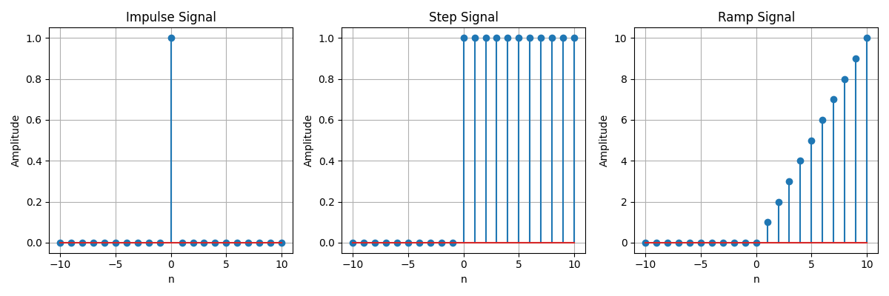
Purpose:
The purpose of this assignment is to:
- Understand and analyze three fundamental discrete-time signals: Impulse Signal, Step Signal, and Ramp Signal.
- Implement these signals programmatically using Python and visualize them using Matplotlib.
- Gain insight into the characteristics and applications of these signals in signal processing and system analysis.
- Develop skills in generating and plotting discrete-time signals for further analysis and system design.
Experiment No:02
Title:
Signal Operations: Addition, Multiplication, Scaling, Shifting, and Folding

Theory:

1. Signal Addition:
Signal addition involves adding two signals pointwise. If $x_{2}$[n] and $x_{2}$[n] are two signals, their sum y[n] is given by:
y[n] =$x_{1}$[n] + $x_{2}$[n]
2. Signal Multiplication:
Signal multiplication involves multiplying two signals pointwise. If $x_{1}$[n] and $x_{2}$[n] are two signals, their product y[n] is given by:
y[n] =$x_{1}$[n] $∙$ $x_{2}$[n]

3. Signal Scaling:
Signal scaling involves multiplying a signal by a constant factor. If x[n] is a signal and α is a scaling factor, the scaled signal y[n] is given by:
$y[n] = α⋅ x[n]$
4. Signal Shifting:
Signal shifting involves shifting a signal in time. If $x[n]$ is a signal and $n_{0}$is the shift amount, the shifted signal $y[n]$is given by:
$y[n]$ = $x[n-n_{0}]$
5. Signal Folding:
Signal folding involves reflecting a signal about the origin. If x[n] is a signal, the folded signal y[n] is given by:
$y[n]$ = $x[-n]$
Source Code:
import numpy as np
import matplotlib.pyplot as plt

# Define signal operations
def signal_addition(x1, x2):
return x1 + x2

def signal_multiplication(x1, x2):
return x1 * x2

def signal_scaling(x, alpha):
return alpha * x

def signal_shifting(n, shift):
return n + shift

def signal_folding(x):
return np.flip(x)

# Define input signals and time axis
n = np.array([-2, -1, 0, 1, 2])
x1 = np.array([1, 2, 3, 4, 5])
x2 = np.array([5, 4, 3, 2, 1])

# Perform signal operations
added_signal = signal_addition(x1, x2)
multiplied_signal = signal_multiplication(x1, x2)
scaled_signal = signal_scaling(x1, 2)
shifted_signal1 = signal_shifting(n, -2)
shifted_signal2 = signal_shifting(n, 2)
folded_signal = signal_folding(x1)

# Plot the results
plt.figure(figsize=(12, 10))

plt.subplot(4, 2, 1)
plt.stem(n, x1)
plt.xlabel("Time")
plt.ylabel("Amplitude")
plt.title("Original Signal x1")
plt.grid()

plt.subplot(4, 2, 2)
plt.stem(n, x2)
plt.xlabel("Time")
plt.ylabel("Amplitude")
plt.title("Original Signal x2")
plt.grid()

plt.subplot(4, 2, 3)
plt.stem(n, added_signal)
plt.xlabel("Time")
plt.ylabel("Amplitude")
plt.title("Signal Addition")
plt.grid()

plt.subplot(4, 2, 4)
plt.stem(n, multiplied_signal)
plt.xlabel("Time")
plt.ylabel("Amplitude")
plt.title("Signal Multiplication")
plt.grid()

plt.subplot(4, 2, 5)
plt.stem(n, scaled_signal)
plt.xlabel("Time")
plt.ylabel("Amplitude")
plt.title("Scaled Signal (x1 * 2)")
plt.grid()

plt.subplot(4, 2, 6)
plt.stem(shifted_signal1, x1)
plt.xlabel("Time")
plt.ylabel("Amplitude")
plt.title("Shifted Signal (Shift = -2)")
plt.grid()

plt.subplot(4, 2, 7)
plt.stem(shifted_signal2, x1)
plt.xlabel("Time")
plt.ylabel("Amplitude")
plt.title("Shifted Signal (Shift = +2)")
plt.grid()

plt.subplot(4, 2, 8)
plt.stem(n, folded_signal)
plt.xlabel("Time")
plt.ylabel("Amplitude")
plt.title("Folded Signal (x1)")
plt.grid()

plt.tight_layout()
plt.show()

Input:
- Input Signals:
  - $x_{1}[n]$=[1,2,3,4,
$x_{2}[n]$=[5,4,3,2,1]
- Time Axis:
n=[−2,−1,0,1,2]
Output:
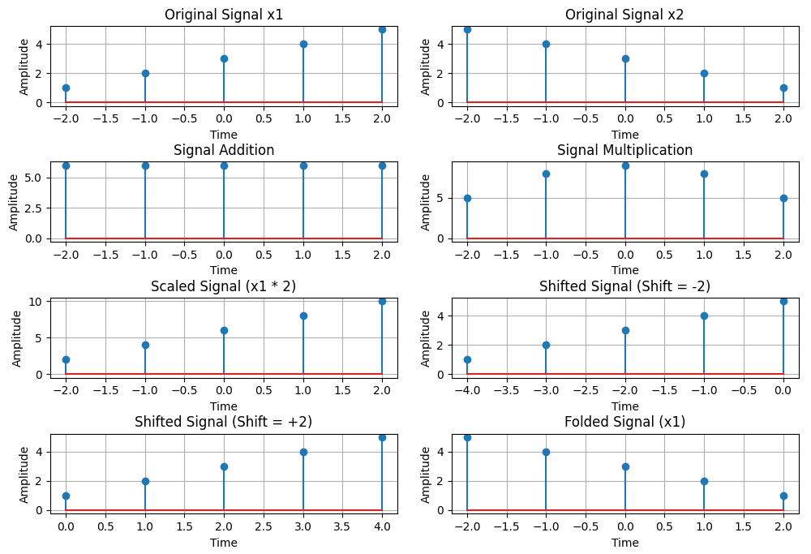
Purpose:
The purpose of this assignment is to:
- Understand and implement basic signal operations such as addition, multiplication, scaling, shifting, and folding.
- Visualize the effects of these operations on discrete-time signals.
- Gain hands-on experience in manipulating signals using Python and Matplotlib.

Experiment No:03.
Title:
Correlation: Analysis of Autocorrelation and Cross-Correlation of Signals

Theory:

Correlation:
Correlation is a mathematical operation used to measure the similarity between two signals. It is widely used in signal processing to identify patterns, detect delays, and analyze signal properties. There are two types of correlation:
- Autocorrelation: Measures the similarity of a signal with a delayed version of itself.
- Cross-Correlation: Measures the similarity between two different signals.

1. Autocorrelation:
Autocorrelation is the correlation of a signal with itself. It is used to identify repeating patterns or periodicities in a signal. Mathematically, the autocorrelation Rxx of a signal x(t) is defined as:
$R_{xx}(τ) =$$\int_{-∞}^{∞}{}x(t)⋅ x(t-τ)dt$
In discrete-time systems, it is defined as:
$R_{xx}[k] =$$\sum_{n=-∞}^{∞}{}x[n]⋅ x[n-k]$
2. Cross-Correlation:
Cross-correlation measures the similarity between two signals x(t) and y(t). It is used to determine the time delay between two signals or to detect the presence of a known signal in a noisy environment. Mathematically, the cross-correlation Rxy is defined as:
$R_{xy}(τ) =$$\int_{-∞}^{∞}{}x(t)⋅ y(t-τ)dt$
In discrete-time systems, it is defined as:
$R_{xy}[k] =$$\sum_{n=-∞}^{∞}{}x[n]⋅ y[n-k]$
Source Code:
import numpy as np
import matplotlib.pyplot as plt
from scipy.signal import correlate, correlation_lags

# Function to compute autocorrelation
def compute_autocorrelation(signal):
auto_corr = correlate(signal, signal, mode='full', method='auto')
lags = correlation_lags(len(signal), len(signal), mode='full')
return auto_corr, lags

# Function to compute cross-correlation
def compute_cross_correlation(signal1, signal2):
cross_corr = correlate(signal1, signal2, mode='full', method='auto')
lags = correlation_lags(len(signal1), len(signal2), mode='full')
return cross_corr, lags

# Define parameters
fs = 1000
t = np.linspace(0, 1, fs, endpoint=False)
freq = 5
sin_signal = np.sin(2 * np.pi * freq * t)

# Compute autocorrelation
auto_corr, lags_auto = compute_autocorrelation(sin_signal)

# Compute cross-correlation between original and shifted signal
signal1 = sin_signal
signal2 = np.roll(signal1, 100)
cross_corr, lags_cross = compute_cross_correlation(signal1, signal2)

# Compute cross-correlation with a noisy signal
noise = np.random.normal(0, 0.5, fs)
noisy_signal = signal1 + noise
cross_corr_noise, lags_noise = compute_cross_correlation(signal1, noisy_signal)

# Plot results
plt.figure(figsize=(10, 8))

plt.subplot(3, 1, 1)
plt.plot(lags_auto, auto_corr)
plt.title("Autocorrelation of a Sinusoidal Signal")
plt.xlabel("Lag")
plt.ylabel("Autocorrelation")
plt.grid()

plt.subplot(3, 1, 2)
plt.plot(lags_cross, cross_corr)
plt.title("Cross-Correlation between Two Signals")
plt.xlabel("Lag")
plt.ylabel("Cross-Correlation")
plt.grid()

plt.subplot(3, 1, 3)
plt.plot(lags_noise, cross_corr_noise)
plt.title("Cross-Correlation with Noisy Signal")
plt.xlabel("Lag")
plt.ylabel("Cross-Correlation")
plt.grid()

plt.tight_layout()
plt.show()
Input:
Sinusoidal Signal:
A sinusoidal signal with a frequency of 5 Hz is generated using:
sin_signal = np.sin(2 * np.pi * freq * t)
Shifted Signal:
The original sinusoidal signal is shifted by 100 samples using:
signal2 = np.roll(signal1, 100)
Noisy Signal:
Gaussian noise is added to the original signal using:
noisy_signal = signal1 + noise
Output:
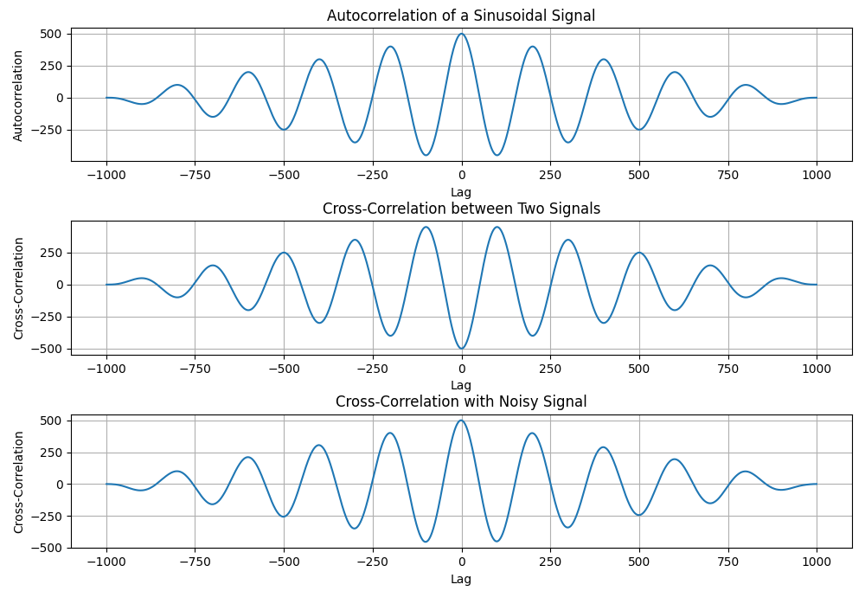
Purpose:
The purpose of this assignment is to:
- Understand the concept of correlation in signal processing, including autocorrelation and cross-correlation.
- Implement autocorrelation and cross-correlation using Python and visualize the results.
- Analyze the effects of signal shifting and noise on correlation.
- Gain practical experience in using correlation to measure similarity between signals and detect time delays.
Experiment No:04
Title:
Convolution: Analysis of Autoconvolution and Convolution of Signals

Theory:

Convolution:
Convolution is a mathematical operation used to combine two signals, producing a third signal that represents how the shape of one signal is modified by the other. It is widely used in signal processing, image processing, and system analysis. Mathematically, the convolution of two signals x(t) and h(t) is defined as:
$y(t) =x(t)∗h(t)=$$\int_{-∞}^{∞}{}x(τ)⋅ h(t-τ)dt$
$y[n] =x[n] ∗h[n]=$$\sum_{k=-∞}^{∞}{}x[k]⋅ h[n-k]$
1. Autoconvolution:
Autoconvolution is the convolution of a signal with itself. It is used to analyze the properties of a signal, such as its symmetry or periodicity. Mathematically, the autoconvolution of a signal x(t) is:
$y(t) =x(t)∗x(t)$
2. Convolution with Shifted and Noisy Signals:
Convolution can also be performed between a signal and its shifted version or a noisy version. This helps in understanding how delays or noise affect the output of a system.
Source Code:
import numpy as np
import matplotlib.pyplot as plt
from scipy.signal import convolve

# Function to compute convolution
def compute_convolution(signal1, signal2):
conv_result = convolve(signal1, signal2, mode='full', method='auto')
return conv_result

# Define parameters
fs = 1000
t = np.linspace(0, 1, fs, endpoint=False)
freq = 5
sin_signal = np.sin(2 * np.pi * freq * t)

# Compute autoconvolution
conv_auto = compute_convolution(sin_signal, sin_signal)

# Compute convolution between original and shifted signal
signal1 = sin_signal
signal2 = np.roll(signal1, 100)
conv_shifted = compute_convolution(signal1, signal2)

# Compute convolution with a noisy signal
noise = np.random.normal(0, 0.5, fs)
noisy_signal = signal1 + noise
conv_noisy = compute_convolution(signal1, noisy_signal)

# Plot results
plt.figure(figsize=(10, 8))

plt.subplot(3, 1, 1)
plt.plot(conv_auto)
plt.title("Autoconvolution of a Sinusoidal Signal")
plt.xlabel("Samples")
plt.ylabel("Convolution Output")
plt.grid()

plt.subplot(3, 1, 2)
plt.plot(conv_shifted)
plt.title("Convolution between Signal and Shifted Version")
plt.xlabel("Samples")
plt.ylabel("Convolution Output")
plt.grid()

plt.subplot(3, 1, 3)
plt.plot(conv_noisy)
plt.title("Convolution with Noisy Signal")
plt.xlabel("Samples")
plt.ylabel("Convolution Output")
plt.grid()

plt.tight_layout()
plt.show()
Input:
sin_signal = np.sin(2 * np.pi * freq * t)
Output:
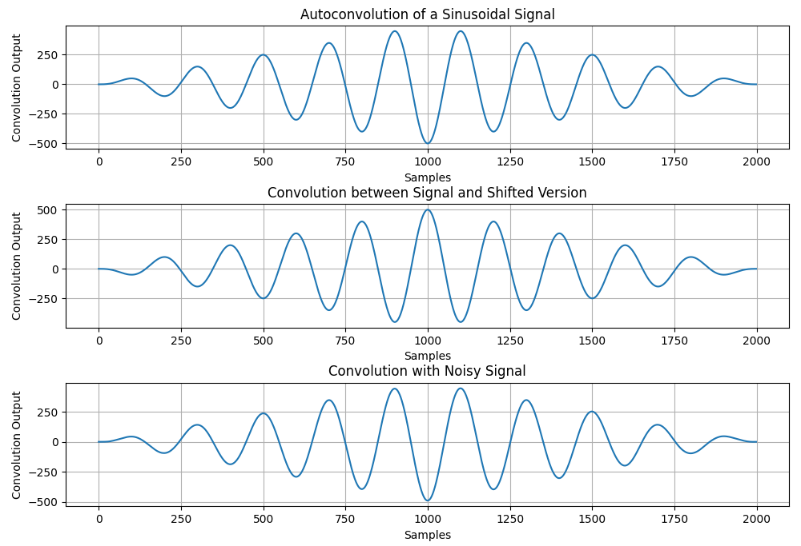
Purpose:
The purpose of this assignment is to:
- Understand the concept of convolution in signal processing and its applications in analyzing linear time-invariant (LTI) systems.
- Implement convolution operations using Python and visualize the results.
- Analyze the effects of autoconvolution, convolution with a shifted signal, and convolution with a noisy signal.
- Gain practical experience in using convolution to study signal interactions and system responses.
- Develop skills in signal processing and visualization using Python libraries such as NumPy, SciPy, and Matplotlib.
Experiment No:05
Title:
PPG Signal Processing: Heart Rate and Abnormality Detection.
Theory:

1. Photoplethysmogram (PPG) Signal:
The PPG signal is a non-invasive optical technique used to detect blood volume changes in the microvascular bed of tissue. It is commonly used in wearable devices to measure heart rate and oxygen saturation (SpO2). The PPG signal consists of:
- Systolic Peak: Corresponds to the heartbeat.
- Diastolic Peak: Corresponds to the relaxation phase of the heart.
- Dicrotic Notch: A small downward deflection in the signal.

2. Signal Processing Steps:
- Bandpass Filtering: Removes noise and artifacts from the raw PPG signal.
- Normalization: Scales the signal to a range of [0, 1] for easier analysis.
- Peak Detection: Identifies systolic peaks in the PPG signal.
- Heart Rate Calculation: Computes the heart rate using the time intervals between peaks.
- Abnormality Detection: Identifies abnormal peaks that deviate significantly from the average RR interval.

3. Applications:
- Heart rate monitoring.
- Detection of arrhythmias and other cardiovascular abnormalities.
- Wearable health monitoring devices.

Source Code:
import numpy as np
import scipy.signal as signal
import matplotlib.pyplot as plt

# Bandpass filter function
def bandpass_filter(data, fs=100):
b, a = signal.butter(4, [0.5 / (0.5 * fs), 5.0 / (0.5 * fs)], btype='band')
return signal.filtfilt(b, a, data)

# Peak detection function
def detect_peaks(signal_data):
peaks, _ = signal.find_peaks(signal_data, distance=50, height=0.3)
return peaks

# Heart rate extraction function
def extract_heart_rate(peaks, fs=100):
if len(peaks) < 2:
return 0
rr_intervals = np.diff(peaks) / fs
return 60 / np.mean(rr_intervals)

# Abnormality detection function (if RR intervals vary drastically)
def detect_abnormalities(peaks, fs=100):
rr_intervals = np.diff(peaks) / fs
mean_rr = np.mean(rr_intervals)
abnormal_peaks = [i for i, rr in enumerate(rr_intervals) if abs(rr - mean_rr) > 0.2 * mean_rr]
return abnormal_peaks

# Generate synthetic PPG signal
fs = 100
t = np.linspace(0, 10, fs * 10)
sine_signal = np.sin(2 * np.pi * 1.2 * t)
noise_signal = 0.1 * np.random.normal(0, 1, len(t))
ppg_signal = sine_signal + noise_signal

# Process PPG signal
filtered_signal = bandpass_filter(ppg_signal, fs)
normalized_signal = (filtered_signal - np.min(filtered_signal)) / (np.max(filtered_signal) - np.min(filtered_signal))
peaks = detect_peaks(normalized_signal)
heart_rate = extract_heart_rate(peaks, fs)
abnormalities = detect_abnormalities(peaks, fs)

# Print results
print(f"Estimated Heart Rate: {heart_rate:.2f} BPM")
print(f"Detected Abnormalities: {len(abnormalities)}")

# Plot Results
plt.figure(figsize=(15, 10))

plt.subplot(4, 1, 1)
plt.plot(t, ppg_signal, label='Raw PPG Signal')
plt.xlabel("Time")
plt.ylabel("Amplitude")
plt.legend()
plt.grid()

plt.subplot(4, 1, 2)
plt.plot(t, filtered_signal, label='Filtered Signal')
plt.xlabel("Time")
plt.ylabel("Amplitude")
plt.legend()
plt.grid()

plt.subplot(4, 1, 3)
plt.plot(t, normalized_signal, label='Normalized Signal')
plt.xlabel("Time")
plt.ylabel("Amplitude")
plt.legend()
plt.grid()

plt.subplot(4, 1, 4)
plt.plot(t, normalized_signal, label='Peak Detection')
plt.plot(t[peaks], normalized_signal[peaks], 'ro', label='Detected Peaks')
for ab in abnormalities:
plt.plot(t[peaks[ab]], normalized_signal[peaks[ab]], 'kx', label='Abnormal Peak')
plt.xlabel("Time")
plt.ylabel("Amplitude")
plt.legend()
plt.grid()

plt.tight_layout()
plt.show()
Input:
- Synthetic PPG Signal:
  - A synthetic PPG signal is generated using a sine wave with added noise:
sine_signal = np.sin(2 * np.pi * 1.2 * t)
noise_signal = 0.1 * np.random.normal(0, 1, len(t))
ppg_signal = sine_signal + noise_signal

2.Sampling Frequency:
The sampling frequency is set to 100 Hz:
fs = 100

Output:
Estimated Heart Rate: 71.90 BPM

Detected Abnormalities: 0
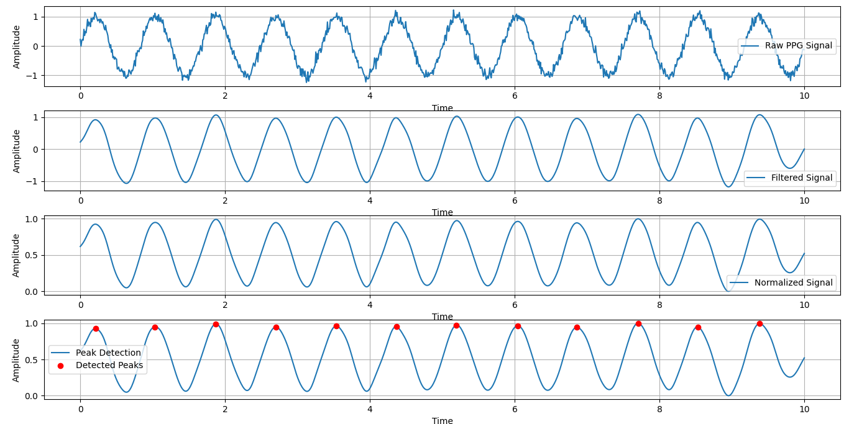

Purpose:
The purpose of this assignment is to:
- Understand the Photoplethysmogram (PPG) signal and its applications in heart rate monitoring.
- Implement signal processing techniques such as filtering, normalization, and peak detection on a synthetic PPG signal.
- Extract heart rate and detect abnormalities in the PPG signal.
- Gain practical experience in processing and analyzing biomedical signals using Python.
- Develop skills in signal filtering, peak detection, and visualization using Python libraries such as NumPy, SciPy, and Matplotlib.
Experiment No:06
Title:
Fourier Series: Approximation of a Square Wave

Theory:

1. Fourier Series:
The Fourier series is a mathematical tool used to represent a periodic function as a sum of sine and cosine functions. It is widely used in signal processing, physics, and engineering to analyze and synthesize periodic signals. The Fourier series of a periodic function f(x) with period 2π is given by:
$f(x) = \frac{a_{0}}{2}+ \sum_{n=1}^{∞}{}(a_{n}cos(nx) + b_{n}sin(nx))$
where:
$a_{n}$ = $\frac{1}{π}\int_{-π}^{π}{}f(x)cos(nx)dx$
$b_{n}$ = $\frac{1}{π}\int_{-π}^{π}{}f(x)sin(nx)dx$
2. Square Wave:
A square wave is a periodic waveform that alternates between two levels (e.g., 1 and -1) with a 50% duty cycle. The Fourier series of a square wave consists of odd harmonics of sine functions:

$f(x) = \frac{4}{π}\left(sin(x) + \frac{1}{3}sin(3x) + \frac{1}{5}sin(5x) + ⋅⋅⋅⋅⋅\right)$
3. Fourier Series Approximation:
The Fourier series approximation involves truncating the infinite series to a finite number of terms. As the number of terms increases, the approximation becomes more accurate.

Source Code:
import numpy as np
import matplotlib.pyplot as plt

# Fourier Series Approximation Function
def fourier_series(x, terms):
if terms < 1:
raise ValueError("Number of terms must be at least 1")

result = np.zeros_like(x) # Initialize result with zeros

for n in range(1, terms + 1, 2): # Iterate over odd numbers (1, 3, 5,...)
result += (4 / (np.pi * n)) * np.sin(n * x) # Fourier series formula

return result

# Define the Original Square Wave Function
def square_wave(x):
return np.where(np.sin(x) >= 0, 1, -1) # Generates a square wave

# Generate X Values
t = np.linspace(-np.pi, np.pi, 400)

# Plot the Approximations
plt.figure(figsize=(8, 6))

# Plot the Original Square Wave
plt.plot(t, square_wave(t), label='Original Square Wave', linestyle='--', color='black')

# Plot Fourier Series Approximations with Different Terms
for terms in [1, 3, 5, 9]:
plt.plot(t, fourier_series(t, terms), label=f'{terms} terms')

# Add Grid and Labels
plt.axhline(0, color='black', linewidth=0.5, linestyle='--')
plt.title('Fourier Series Approximation of a Square Wave')
plt.xlabel('Time')
plt.ylabel('Amplitude')
plt.legend()
plt.grid(True)

# Show the Plot
plt.show()

Input:
1.Time Vector:
t = np.linspace(-np.pi, np.pi, 400)
This creates 400 points between −π and π.

2.Square Wave Function:
def square_wave(x):

return np.where(np.sin(x) >= 0, 1, -1)
3.Fourier Series Terms:
The Fourier series approximation is computed for different numbers of terms: 1, 3, 5, and 9.

Output:
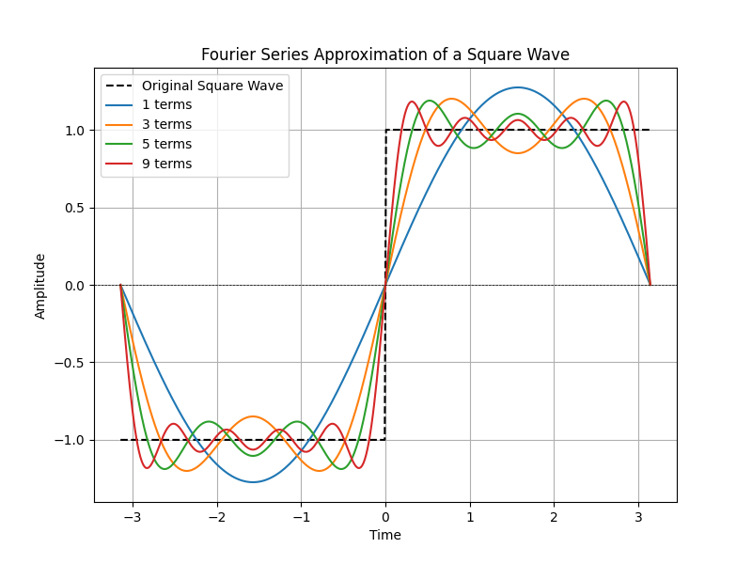
Purpose:

The purpose of this assignment is to:

Understand the concept of Fourier Series and its application in approximating periodic signals, such as a square wave.

Implement the Fourier Series approximation of a square wave using Python and visualize the results.

Analyze how increasing the number of terms in the Fourier Series improves the approximation of the square wave.

Gain practical experience in using Fourier Series to decompose and reconstruct signals.

Experiment No:07
Title:

Fourier Series Decomposition: Analysis of a Square Wave

Theory:

1. Fourier Series Decomposition:

Fourier series decomposition is the process of breaking down a periodic function into a sum of sine and cosine functions. This is achieved by calculating the Fourier coefficients $a_{0}$, $a_{n}$and $b_{n}$which represent the amplitude of the cosine and sine terms in the series. The Fourier series of a periodic function $f(x)$with period T is given by:
$f(x) = \frac{a_{0}}{2}+ \sum_{n=1}^{∞}{}(a_{n}cos(\frac{2πnx}{T}) + b_{n}sin(\frac{2πnx}{T}))$
where:
$a_{0}$ = $\frac{2}{T}\int_{-T/2}^{T/2}{}f(x)dx$
$a_{n}$ = $\frac{2}{T}\int_{-T/2}^{T/2}{}f(x)cos(\frac{2πnx}{T})dx$
$b_{n}$ = $\frac{2}{T}\int_{-T/2}^{T/2}{}f(x)sin(\frac{2πnx}{T})dx$
2.Square Wave:
A square wave is a periodic waveform that alternates between two levels (e.g., 1 and -1) with a 50% duty cycle. The Fourier series of a square wave consists of odd harmonics of sine functions:
$f(x) = \frac{4}{π}\left(sin(x) + \frac{1}{3}sin(3x) + \frac{1}{5}sin(5x) + ⋅⋅⋅⋅⋅\right)$

3. Fourier Coefficients:

The coefficients $a_{0}$,$a_{n}$ and${ b}_{n}$ are calculated using numerical integration. These coefficients determine the contribution of each harmonic to the overall signal.

Source Code:
import numpy as np

from scipy.integrate import quad

# Define the function to decompose (Example: Square Wave)

def f(x):

return np.where(np.sin(x) >= 0, 1, -1) # Square wave function

# Fourier Series Coefficients Calculation

def fourier_coefficients(f, T, N):

L = T / 2 # Half period

a0 = (1 / L) * quad(lambda x: f(x), -L, L)[0] # Compute a0

an = np.zeros(N)

bn = np.zeros(N)

for n in range(1, N + 1):

an[n-1] = (1 / L) * quad(lambda x: f(x) * np.cos(n * np.pi * x / L), -L, L)[0]

bn[n-1] = (1 / L) * quad(lambda x: f(x) * np.sin(n * np.pi * x / L), -L, L)[0]

return a0, an, bn

# Parameters

T = 2 * np.pi # Period of the function

N = 10 # Number of terms

# Compute Fourier Coefficients

a0, an, bn = fourier_coefficients(f, T, N)

# Display Fourier Coefficients

np.set_printoptions(precision=5, suppress=True) # Format output for readability

print("a0:", a0)

print("an:", an)

print("bn:", bn)
Input:

1.Square Wave Function
def f(x):

return np.where(np.sin(x) >= 0, 1, -1)

2.Period T:
T = 2 * np.pi
3.Number of Terms N:
N = 10
Output:
$a_{0}$: 0.0

$a_{n}$: [0. 0. 0. 0. 0. 0. 0. 0. 0. 0.]

$b_{n}$: [ 1.27324 0. 0.42441 0. 0.25465 0. 0.18189 -0.

0.14147 -0. ]
Explanation of Output:
$a_{0}$:The DC component is 0, which is expected for a square wave.

$a_{n}$:All cosine coefficients are 0, as the square wave is an odd function.

$b_{n}$:The sine coefficients are non-zero for odd harmonics, consistent with the Fourier series of a square wave.

Purpose:

The purpose of this assignment is to:

1.Understand the concept of Fourier series decomposition and its application in analyzing periodic signals.

2.Compute the Fourier coefficients $(a_{0}$,$a_{n}$,$b_{n})$for a square wave.

3.Verify the theoretical properties of Fourier series, such as the absence of cosine terms (

$a_{0}$) for odd functions like the square wave.

4.Gain hands-on experience in using numerical integration to calculate Fourier coefficients.
Experiment No: 08
Title:

Discrete Fourier Transform (DFT) and Inverse Discrete Fourier Transform (IDFT)

Theory:

1. Discrete Fourier Transform (DFT):

The Discrete Fourier Transform (DFT) is a mathematical technique used to transform a discrete-time signal from the time domain to the frequency domain. For a sequence x[n] of length N, the DFT X[k] is defined as:

$X[k] = \sum_{n=0}^{N-1}{}x[n] ⋅e^{-j\frac{2π}{N}kn},$ k=0,1,,,,,N-1
where:

X[k] is the DFT of the sequence x[n].

k is the frequency bin index.

N is the length of the sequence.

2. Inverse Discrete Fourier Transform (IDFT):

The Inverse Discrete Fourier Transform (IDFT) is used to reconstruct the original time-domain signal from its frequency-domain representation. The IDFT is defined as:

$x[n] = \frac{1}{N}\sum_{n=0}^{N-1}{}X[k] ⋅e^{j\frac{2π}{N}kn},$ n=0,1,,,,,N-1
where:

x[n] is the reconstructed time-domain signal.

X[k] is the DFT of the sequence.

3. Frequency Bins:

The frequency bins represent the discrete frequencies at which the DFT is computed. For a sequence of length N, the frequency bins are given by:
$f_{k}= \frac{k}{N},$ k = 0,1,,,,N-1
Source Code:
import numpy as np
import matplotlib.pyplot as plt
# Input sequence and N
x = [1,1,1,1]
N= 4
x = np.pad(x, (0, N - len(x)), mode='constant')
# DFT computation
X = np.fft.fft(x, N)
# IDFT computation (Inverse DFT)
x_reconstructed = np.fft.ifft(X)

# Compute frequency bins
freq_bins = np.fft.fftfreq(N)
# Print the DFT and IDFT values
print("DFT values:", X)
print("Reconstructed IDFT values:", x_reconstructed.real)
print("Frequency bins:", freq_bins)
# Plot the input signal
plt.figure(figsize=(10, 6))
plt.subplot(4, 1, 1)
plt.stem(range(len(x)), x)
plt.title('Input Signal x(n)')
plt.xlabel('n')
plt.ylabel('x(n)')
plt.grid()
# Plot the magnitude of DFT
plt.subplot(4, 1, 2)
plt.stem(range(N), np.abs(X))
plt.title('DFT Magnitude |X(k)|')
plt.xlabel('k')
plt.ylabel('|X(k)|')
plt.grid()

# Plot phase of DFT
plt.subplot(4, 1, 3)
plt.stem(range(N), np.angle(X))
plt.title('DFT Phase ∠X(k)')
plt.xlabel('k')
plt.ylabel('Phase (radians)')
plt.grid()

# Plot the IDFT signal
plt.subplot(4, 1, 4)
plt.stem(range(N), x_reconstructed.real)
plt.title('Reconstructed Signal x(n) from IDFT')
plt.xlabel('n')
plt.ylabel('x(n)')
plt.grid()
plt.tight_layout()
plt.show()
Input:
1.Input Sequence:
x = [1, 1, 1, 1]
2.Length of DFT (N):
N = 4
Output:
DFT values: [4.+0.j 0.+0.j 0.+0.j 0.+0.j]
Reconstructed IDFT values: [1. 1. 1. 1.]
Frequency bins: [ 0. 0.25 -0.5 -0.25]
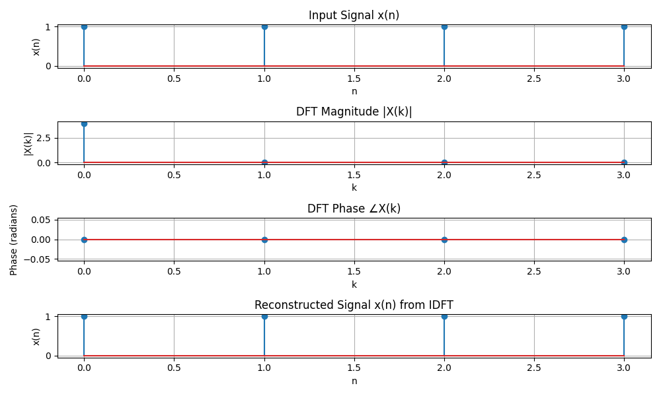
Purpose:
The purpose of this assignment is to:
- Understand the concept of Discrete Fourier Transform (DFT) and Inverse Discrete Fourier Transform (IDFT).
- Compute the DFT and IDFT of a given sequence using Python.
- Analyze the magnitude and phase spectrum of the DFT.
- Reconstruct the original signal from its DFT using IDFT.
- Visualize the input signal, DFT magnitude, DFT phase, and reconstructed signal.

